## Requirement Summary Form

The requirements catalogue also contains a summary of the ongoing and completed requirements detailed on the requirement summary form, a copy of which is in the appendix. The requirement summary form is completed as follows:

* **Analyst Name**- your name as the analyst on this project.
* **System Name**- the proposed system name or an abbreviation of it.
* **Version** - a version number is assigned to a requirement. The initial version of a requirement is number one. However, the requirement may need to be updated in the course of the development of the project, then the requirements catalogue entry will be replaced with the updated version of the requirement and the updated version number will reflect this change.
* **Page**- page numbering will be maintained within the catalogue.
* **Requirement Number** - a unique requirement number is assigned to each requirement. The requirement number is an incremental number starting with one.
* **Requirement Description** - a brief textual description of the requirement.
* 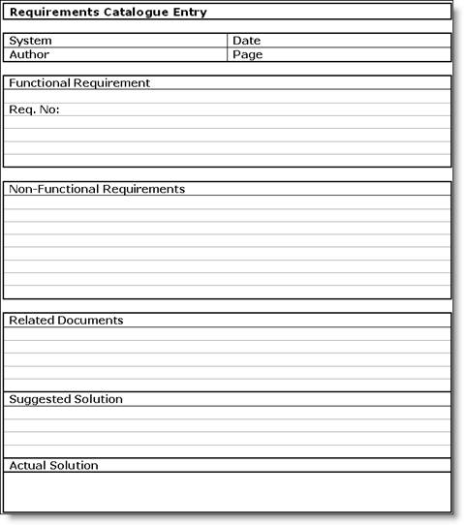**Priority** - a priority is assigned to the requirement. The priority given is agreed between the originator and the analyst. There are three priority levels: high (H), medium (M) and low (L). High priority is assigned when the requirement is mandatory. Medium priority is assigned when the requirement is desirable. Low priority is assigned when the requirement is optional.
* **Originator**- is the originator of the requirement; the person with the responsibility for negotiation about the requirement.
* **Status**- the status of the requirement will be either ongoing or complete. When the status is ongoing, the status box will be empty. When the status is complete the status box will contain a tick (().

The requirements summary is a summary of all the requirements in the catalogue and each summary must reflect accurately the details of the requirement as specified in its requirement catalogue entry, ie requirement numbers, version numbers, priorities and status must match.